**Experiment 6**

**CODE 1:**

**XML CODE:**

<?xml version="1.0" encoding="utf-8"?>

<TableLayout xmlns:android="http://schemas.android.com/apk/res/android"

xmlns:app="http://schemas.android.com/apk/res-auto"

xmlns:tools="http://schemas.android.com/tools"

android:layout_width="match_parent"

android:layout_height="match_parent"

tools:context=".MainActivity">

<TableRow>

<TextView android:text="Student Details"

android:textSize="20dp"

style="@style/TextAppearance.Material3.BodyLarge"

android:layout_marginTop="55dp"

android:layout_marginLeft="130dp"

/>

</TableRow>

<TableRow>

<TextView android:text="Student 1 -> Name: Ethan, Roll-No: 1"

android:textSize="15dp"

android:layout_marginTop="25dp"

android:layout_marginLeft="80dp"/>

</TableRow> <TableRow>

<TextView android:text="Student 2 -> Name: Barry, Roll-No: 2"

android:textSize="15dp"

android:layout_marginTop="25dp"

android:layout_marginLeft="80dp"/>

</TableRow> <TableRow>

<TextView android:text="Student 3 -> Name: John, Roll-No: 3"

android:textSize="15dp"

android:layout_marginTop="25dp"

android:layout_marginLeft="80dp"/>

</TableRow> <TableRow>

<TextView android:text="Student 4 -> Name: Vin, Roll-No: 4"

android:textSize="15dp"

android:layout_marginTop="25dp"

android:layout_marginLeft="80dp"/>

</TableRow> <TableRow>

<TextView android:text="Student 5 -> Name: Mark, Roll-No: 5"

android:textSize="15dp"

android:layout_marginTop="25dp"

android:layout_marginLeft="80dp"/>

</TableRow> <TableRow>

<TextView android:text="Student 6 -> Name: Ethan, Roll-No: 6"

android:textSize="15dp"

android:layout_marginTop="25dp"

android:layout_marginLeft="80dp"/>

</TableRow> <TableRow>

<TextView android:text="Student 7 -> Name: Jack, Roll-No: 7"

android:textSize="15dp"

android:layout_marginTop="25dp"

android:layout_marginLeft="80dp"/>

</TableRow> <TableRow>

<TextView android:text="Student 8 -> Name: Brandi, Roll-No: 8"

android:textSize="15dp"

android:layout_marginTop="25dp"

android:layout_marginLeft="80dp"/>

</TableRow> <TableRow>

<TextView android:text="Student 9 -> Name: Jacob, Roll-No: 9"

android:textSize="15dp"

android:layout_marginTop="25dp"

android:layout_marginLeft="80dp"/>

</TableRow> <TableRow>

<TextView android:text="Student 10 -> Name: Andrew, Roll-No: 10"

android:textSize="15dp"

android:layout_marginTop="25dp"

android:layout_marginLeft="80dp"/>

</TableRow>

</TableLayout>

**JAVA CODE:**

package com.example.experiment6_1;

import androidx.appcompat.app.AppCompatActivity;

import android.os.Bundle;

public class MainActivity extends AppCompatActivity {

@Override

protected void onCreate(Bundle savedInstanceState) {

super.onCreate(savedInstanceState);

setContentView(R.layout.activity_main);

}

}

**Output:**

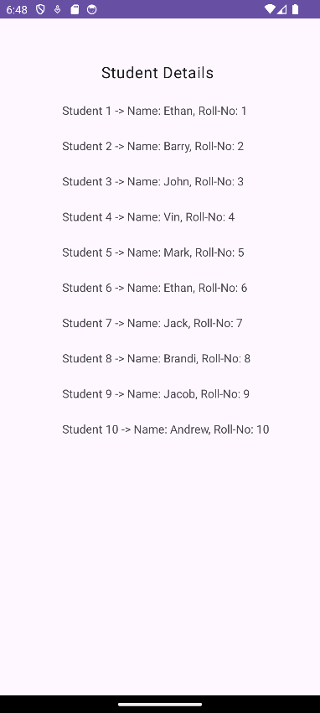

**CODE 1:**

**XML CODE:**

<?xml version="1.0" encoding="utf-8"?>

<FrameLayout

xmlns:android="http://schemas.android.com/apk/res/android"

android:layout_width="match_parent"

android:layout_height="match_parent">

<LinearLayout

android:layout_width="match_parent"

android:layout_height="wrap_content"

android:orientation="vertical"

android:gravity="center">

<TextView

android:id="@+id/data_type_title"

android:layout_width="wrap_content"

android:layout_height="wrap_content"

android:text="Data Types in OOP"

android:textSize="20sp"

android:textStyle="bold" />

<TextView

android:id="@+id/data_type_1"

android:layout_width="wrap_content"

android:layout_height="wrap_content"

android:text="Primitive Data Types:" />

<TextView

android:id="@+id/data_type_list_1"

android:layout_width="wrap_content"

android:layout_height="wrap_content"

android:text="int, float, char, boolean, etc." />

<TextView

android:id="@+id/data_type_2"

android:layout_width="wrap_content"

android:layout_height="wrap_content"

android:text="Reference Data Types:" />

<TextView

android:id="@+id/data_type_list_2"

android:layout_width="wrap_content"

android:layout_height="wrap_content"

android:text="String, Arrays, Objects, etc." />

</LinearLayout>

</FrameLayout>

**JAVA CODE:**

package com.example.experiment6_2;

import androidx.appcompat.app.AppCompatActivity;

import android.os.Bundle;

public class MainActivity extends AppCompatActivity {

@Override

protected void onCreate(Bundle savedInstanceState) {

super.onCreate(savedInstanceState);

setContentView(R.layout.activity_main);

}

}

**Output:**

